Setting up application environment

Docker CLI Installation

(Customer Care Registry_PNT2022TMID52279)

**STEP-1**

Search Docker.com

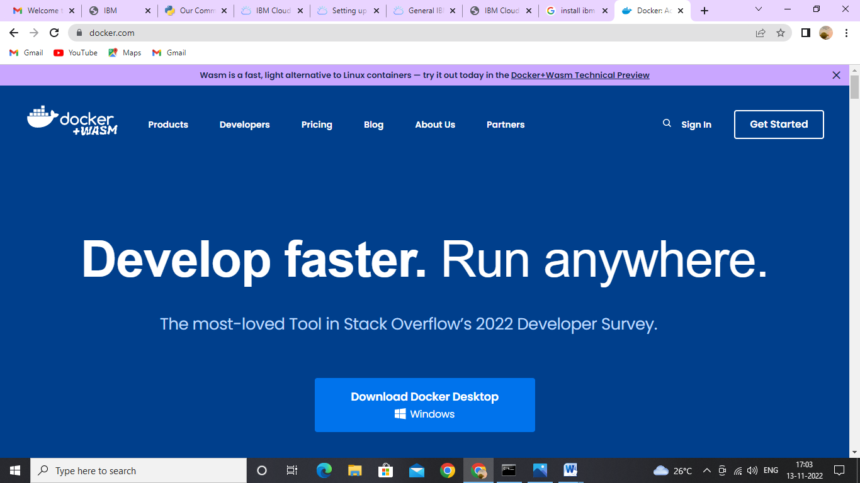

**STEP-2**

Download Docker Desktop from docker.com

